Table of Content

Table of Content 1
ISIS 1
Prefix Suppression 1
Hello Padding 3
Overload Bit 6
LSP Size 8
Default Metric 10
Hello/Hold Timer 11
Mesh Groups 13
Prefix Summarization 15
Default Route Preference 18
ISIS Timers 20
Log Neighbor Changes 22
Troubleshooting 1 – No routes 23
Troubleshooting 2 – Adjacency 24
IPv6 Single Topology 26
IPv6 Single Topology Challenge 27
IPv6 Multitopology 29
IPv6 Single to Multitopology 30
Wide Metrics 32
Route Filtering 34
Backdoor Link 35
Non-Optimal Intra-Area Routing 37
Multi Area 38
BGP 40
Russo – Lab 1 ECMP 40
Russo – Lab 2 UCMP 41

ISIS

Prefix Suppression

Load Config
# IOL
configure replace unix:labconfigs/isis.cfg force

# IOS-XR
configure
load config:labconfigs/isis.cfg
commit replace confirmed minutes 1
commit

- Configure ISIS so that only the loopbacks are advertised into the IGP.
- Only use interface-level commands on R2 and XR2.

Answer
# R1 – R6
router isis
advertise passive-only

# R2
interface Ethernet0/1.12
no isis advertise prefix
interface Ethernet0/1.23
no isis advertise prefix
interface Ethernet0/1.24
no isis advertise prefix

# XR1
router isis 1
address-family ipv4 unicast
advertise passive-only

# XR2
router isis 1
interface GigabitEthernet0/0/0/0.1920
suppressed

Explanation
In ISIS, the link address is not part of the underlying topology. It is simply advertised as an additional prefix in the IP reachability TLV. By configuring advertise passive-only we instruct the router to suppress all prefixes except for the passive interfaces, which in our case is only Lo0.

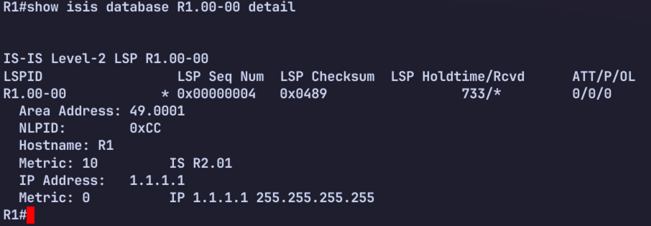
How does R2 have the correct nexthop for R1’s loopback? We don’t see R1 advertising its nexthop anywhere in the LSP. The answer is that R1 advertises its interface address in the Hello. This is how R2 knows what to use for the nexthop to 1.1.1.1.
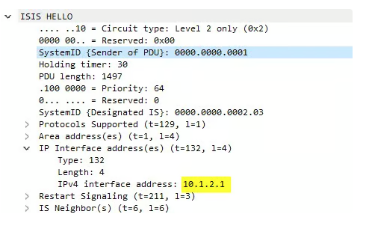

Hello Padding

Load Config
# IOL
configure replace unix:labconfigs/isis.cfg force

# IOS-XR
configure
load config:labconfigs/isis.cfg
commit replace confirmed minutes 1
commit

- Configure R1 and XR2 so that Hellos are only padded the first six times.

Answer

# R1
int Gi2.12
no isis hello padding

! Or

router isis
no hello padding [multi-point|point-to-point]

# XR2
router isis 1
int Gi0/0/0/0.1920
hello-padding sometimes [level 2]

Explanation
By default, the router will always pad Hellos. This can be considered an unnecessary waste of bandwidth, as once you’ve verified MTU via the padded Hellos, you no longer really need to continue to pad Hellos.
When using the above configuration, the router will only pad the first 6 Hellos. After this, all subsequent Hellos are not padded, which saves some bandwidth.
If for some reason you wanted to never pad Hellos, not even at the beginning of the adjacency, you can use no isis hello padding always under the interface on IOS-XE, or hello-padding disable on IOS-XR. This is similar to OSPF’s ip ospf mtu-ignore setting.

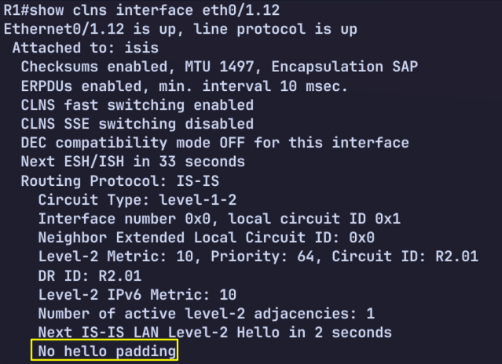

When you use no isis hello padding always, you will instead see “Never pad hello PDU”:

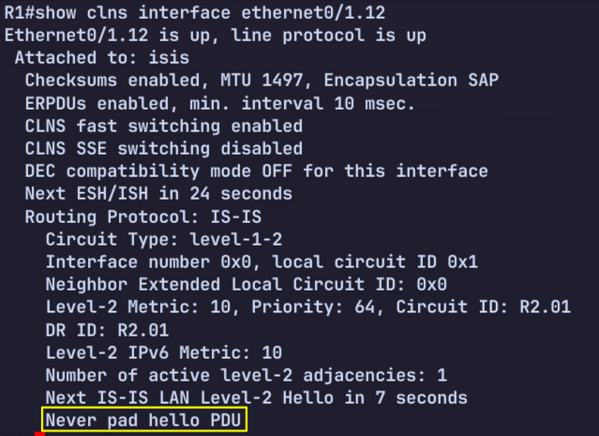

On IOS-XR.
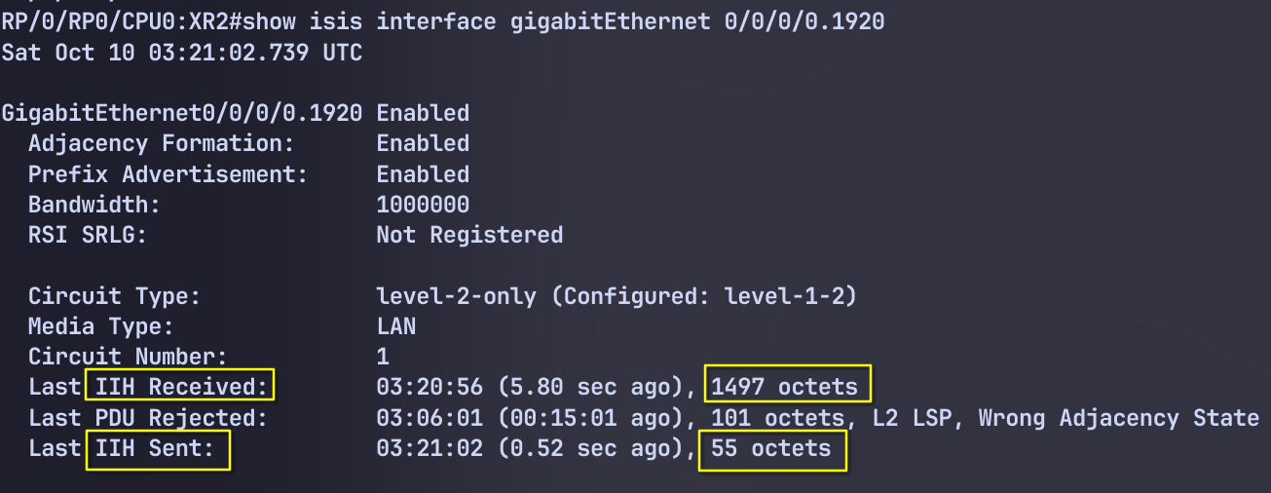
XR2 sent Hello without Padding (55 octets), whilst its neighbor (XR1) sent padded Hello (1497 octets).

Overload Bit

Load Config
# IOL
configure replace unix:labconfigs/isis.cfg force

# IOS-XR
configure
load config:labconfigs/isis.cfg
commit replace confirmed minutes 1
commit

Set the overload bit on routers R2, R3, and XR1:
- On R2, set overload bit on startup, wait for BGP, and supress all external routes
- On R3, set overload bit right now, and advertise all prefixes
- On XR1, set overload bit on startup, wait for BGP, and suppress both inter-area and external routes

Answer

# R2
router isis
set-overload-bit on-startup wait-for-bgp suppress external

# R3
router isis
set-overload-bit

# XR1
router isis 1
set-overload-bit on-startup wait-for-bgp

Explanation

XR1, we can verify overload bit configuration using show isis protocol.
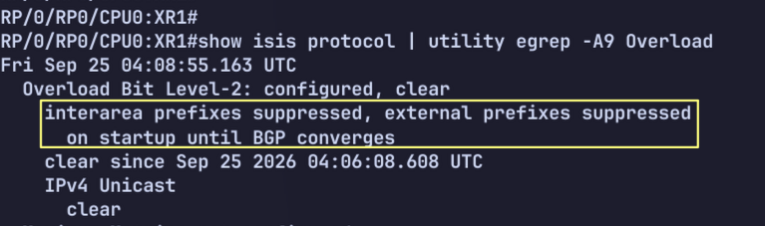

R3 is currently setting the OL bit in its LSP:
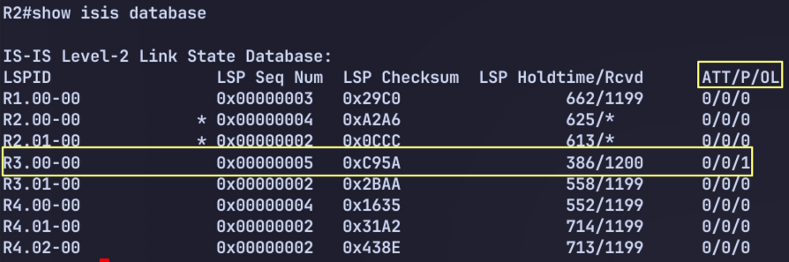
Note that when the OL bit is set, the router is never used for transit, even if no other paths exist. The node can still be used to reach leaf prefixes advertised directly from the node itself, such as its own loopback.

R2 should no longer have ECMP routes to XR1. It should only be using R4 for transit. It will only use R3 for traffic R3 itself is advertising - its loopback and connected routes.
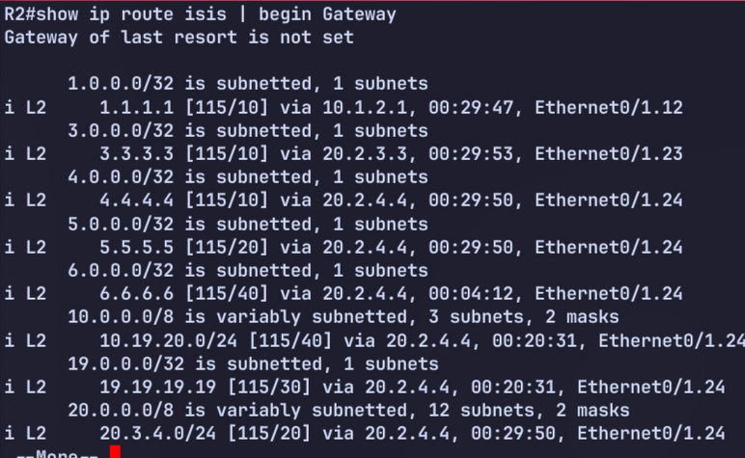
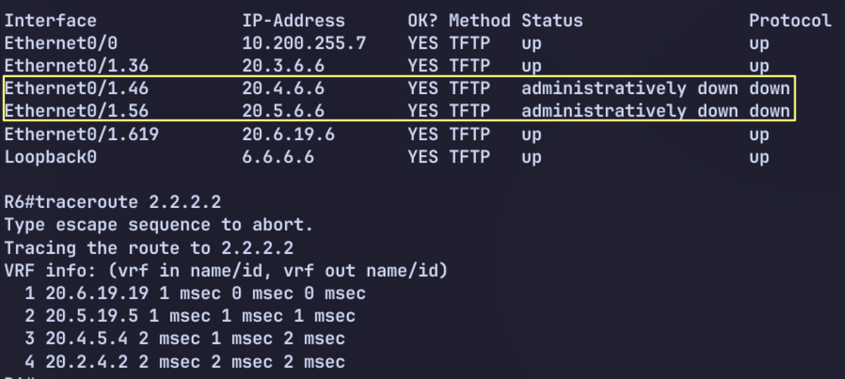

LSP Size
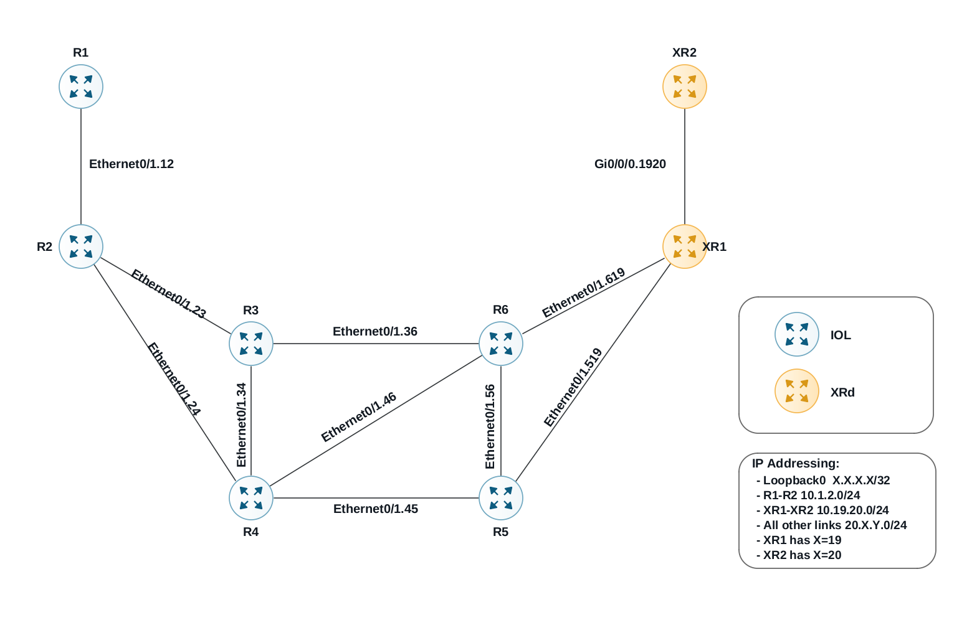
Figure 0-1 ISIS Single Area

Load Config
# IOL
configure replace unix:labconfigs/isis.cfg force

# IOS-XR
configure
load config:labconfigs/isis.cfg
commit replace confirmed minutes 1
commit

- Enable wide metrics everywhere.
- Configure R1 and XR2 so that their LSP is fragmented once is it bigger than 128 bytes.

Answer

# IOL
router isis
metric-style wide

# IOS-XR
router isis 1
address-family ipv4 unicast
metric-style wide

# R1
router isis
lsp-mtu 128

# XR2
router isis 1
lsp-mtu 128

Explanation

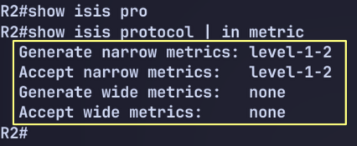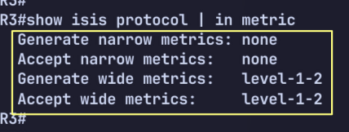

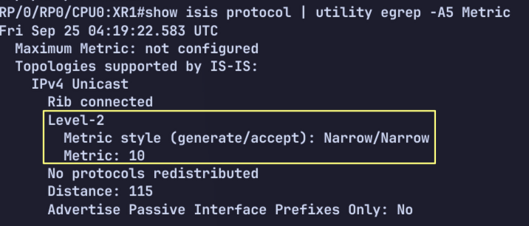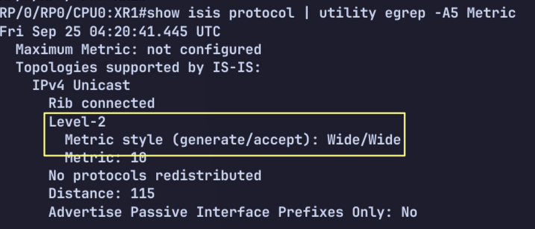
By default, an LSP is fragmented at 1500 bytes. We can control this by setting the lsp-mtu. When the router’s own LSP becomes larger than the specified MTU size, it is split into multiple LSPs.

Default Metric

Load Config
# IOL
configure replace unix:labconfigs/isis.cfg force

# IOS-XR
configure
load config:labconfigs/isis.cfg
commit replace confirmed minutes 1
commit

- Configure all routers so that the default metric is 100.

Answer

# IOL
router isis
metric-style wide
metric 100

# IOS-XR
router isis 1
address-family ipv4 unicast
metric-style wide
metric 100

Explanation

To use a default metric of 100, we must use wide metrics. First we enable wide metrics everywhere.
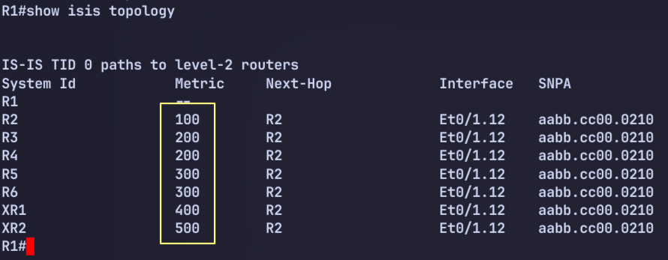
The metric command under the ISIS router process dictates the default metric for all interfaces. Alternatively, you can manually configure the metric under each interface individually.

Hello/Hold Timer

Load Config
# IOL
configure replace unix:labconfigs/isis.cfg force

# IOS-XR
configure
load config:labconfigs/isis.cfg
commit replace confirmed minutes 1
commit

- Change the R1-R2 link to be p2p. Configure the Hello/Hold timers to be 2/6 seconds.
- Change the hello/hold timer on R3 so that its Eth0/1.23 interface uses a hold timer of 3 seconds when it is elected DIS on the LAN.

Answer

# R1 & R2
interface Ethernet0/1.12
isis network point-to-point
isis hello-multiplier 3
isis hello-interval 2

# R3
interface Ethernet0/1.23
isis hello-interval 3
isis hello-multiplier 3

Note : the hello-multiplier command was not strictly necessary above. This is because the default value is 3.

Explanation

Before configuring isis network type
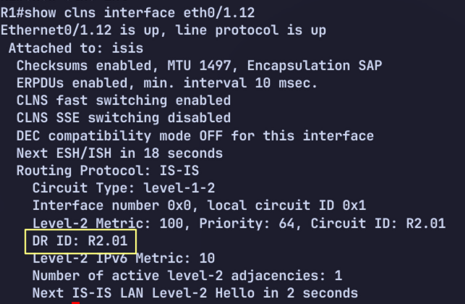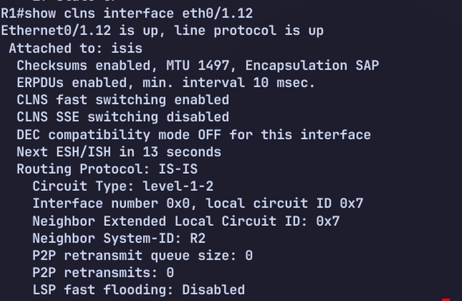

Verify holdtime. This is the Neighbor’s Holdtime, not local timer.

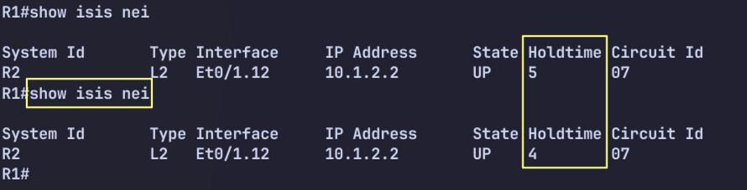

We can verify local timer on IOS-XR.
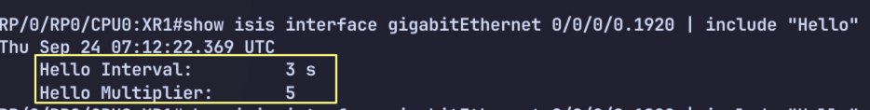

Mesh Groups

Load Config
# IOL
configure replace unix:labconfigs/isis.cfg force

# IOS-XR
configure
load config:labconfigs/isis.cfg
commit replace confirmed minutes 1
commit
Configure R2 so that LSPs received on eth0/1.12 are only forwarded out eth0/1.24. LSPs received on eth0/1.23 should only be flooded out eth0/1.24 as well.

Answer

# R2

interface Ethernet0/1.12
isis mesh-group 10

interface Ethernet0/1.23
isis mesh-group 10

Explanation

By default, an LSP received on any interface will be flooded out all other interfaces. This can be an inefficient use of bandwidth in large scale, highly meshed topologies. To better scale ISIS, we can configure interfaces into groups for flooding.
If an interface belongs to an ISIS mesh-group, any LSP received on that interface is only flooded out other interfaces that are not in the same mesh group.

LSP recv on .12
├──> .23 ❌ same mesh-group
└──> .24 ✅

LSP recv on .23
├──> .12 ❌ same mesh-group
└──> .24 ✅
Before Mesh Group
Shutdown lo0 on R1 to force R1 to update its LSP
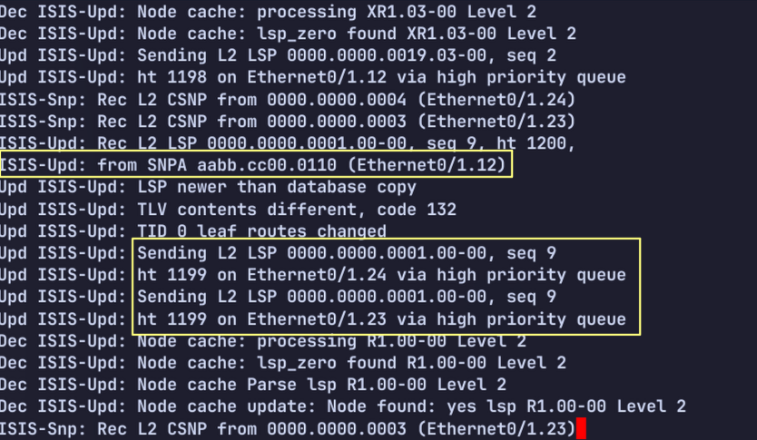

After Mesh Group
LSP received on eth0/1.12 is flooded only to eth0/1.24.
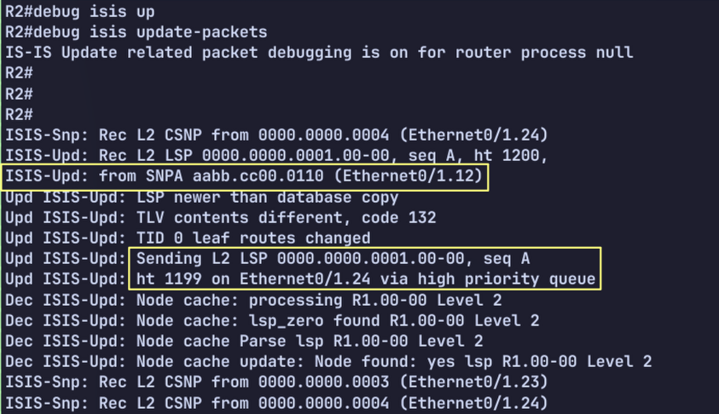

Prefix Summarization

Load Config
# IOL
configure replace unix:labconfigs/isis.inter.area.cfg force

# IOS-XR
configure
load config:labconfigs/isis.inter.area.cfg
commit replace confirmed minutes 1
commit

The topology has been changed so that there are three ISIS areas now.
- Configure R3 and R4 to summarize R1’s loopback as 1.1.1.0/24 into Level 2.
- Configure R4 to summarize R5’s loopback as 5.5.5.0/24 into Level 1. No other prefixes should be leaked into Level 1.
- Configure XR1 to summarize XR2’s loopback as 20.20.20.0/24 into Level 2.
- Configure XR2 to redistribute a new prefix, 20.20.200.20/32 into ISIS and summarize it as 20.20.200.0/24.

Answer

# R3 & R4
router isis
Summary-address 1.1.1.0 255.255.255.0 level-2

# R4

ip prefix-list L2_To_L1 seq 5 permit 5.5.5.5/32

route-map L2_To_L1 permit 0
match ip address prefix-list L2_To_L1

router isis
summary-address 5.5.5.0 255.255.255.0 level-1
redistribute isis ip level-2 into level-1 route-map L2_To_L1

# XR1
router isis 1
address-family ipv4 unicast
summary-prefix 20.20.20.0/24 level 2

# XR2
interface Loopback20
ipv4 address 20.20.200.20 255.255.255.255
!
route-policy Lo20
if destination in (20.20.200.20/32) then
pass
endif
end-policy
!
router isis 1
address-family ipv4 unicast
summary-prefix 20.20.200.0/24
redistribute connected level-1 route-policy Lo20
!
!
end

R1’s Loopback Before / After
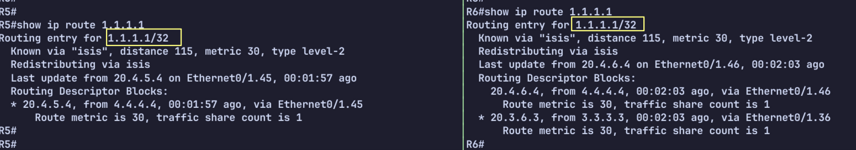
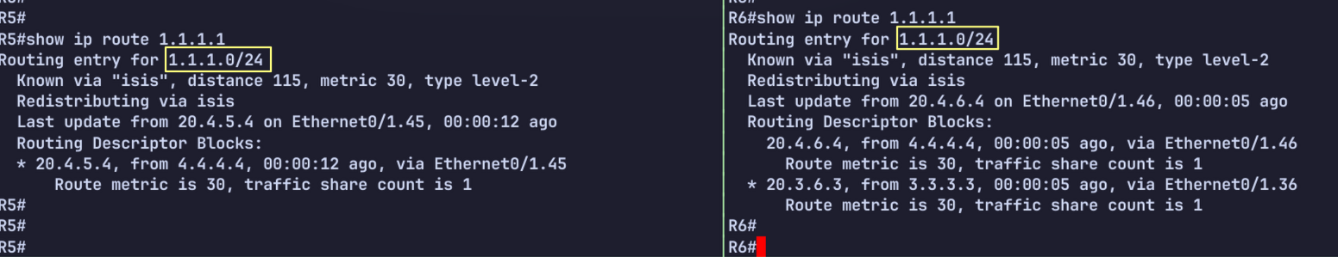
R5’s Loopback Before / After
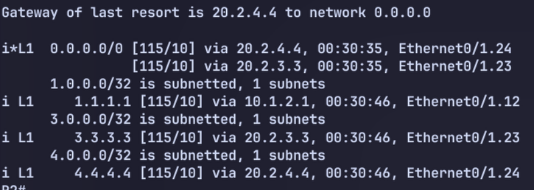
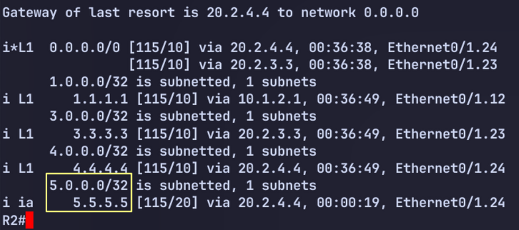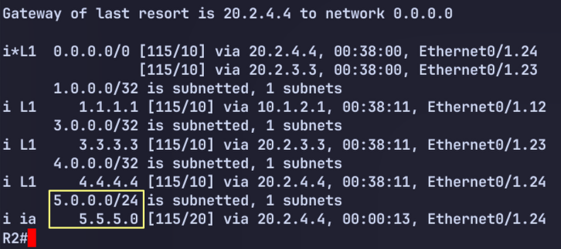

XR2’s Loopback
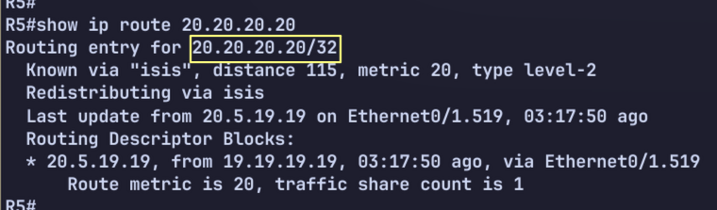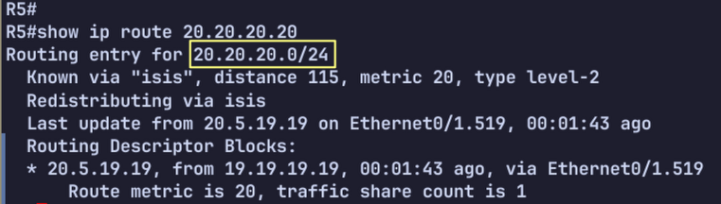

Explanation
When summarizing level 1 prefixes as they are advertised into level 2, you use the command summary-address <prefix> <mask> level-2. Optionally, you can leave the level-2 keyword out, as level 2 is the default.

When summarizing level 2 prefixes as they are advertised into level 1, you must first ensure that the routes are being leaked into level 1 in the first place. Then you use the summary command and specify level-1. The level is always the level you are advertising the prefixes into.

Default Route Preference

Load Config
# IOL
configure replace unix:labconfigs/isis.inter.area.cfg force

# IOS-XR
configure
load config:labconfigs/isis.inter.area.cfg
commit replace confirmed minutes 1
commit

- Configure area 49.1234 so that R2 prefers R3 for the default route, and only uses R4 upon loss of R3. Do not use metrics to achieve this.

Answer

router isis
default-information originate route-map SET_L1
route-map SET_L1 permit 10
set level level-1

Explanation
ISIS allows us to originate a default route just like OSPF. An L1 router will prefer an explicit 0/0 route that is advertised in the area over using the ATT bit.

Before Config
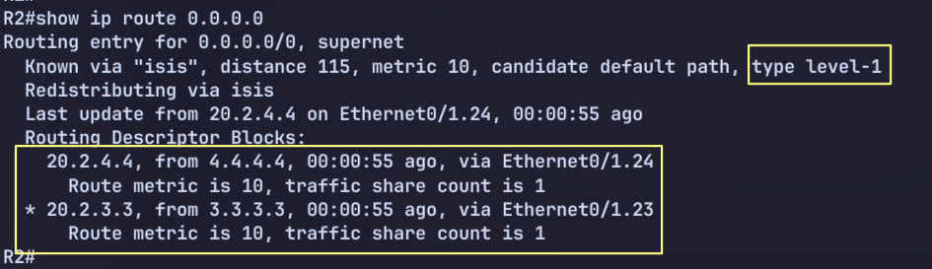

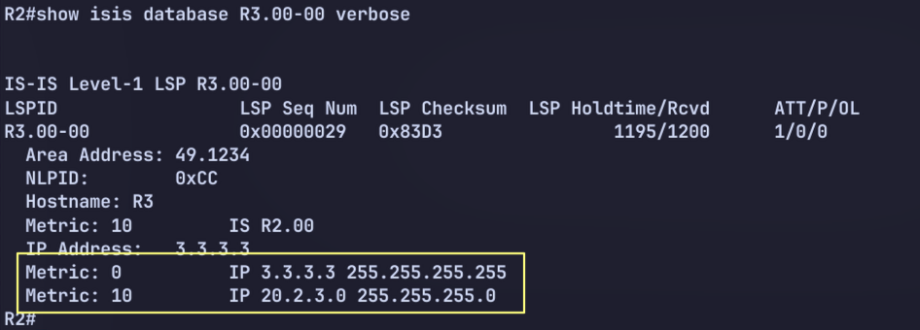

After Configuring default-information originate
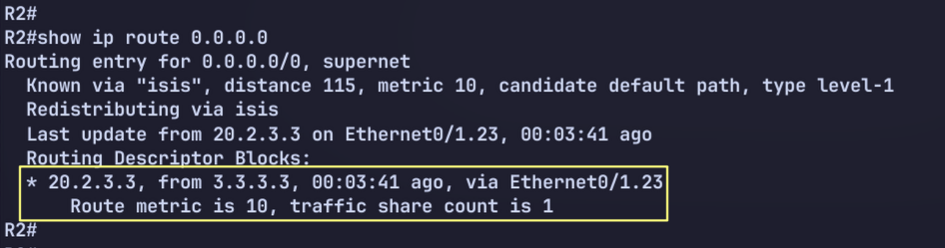
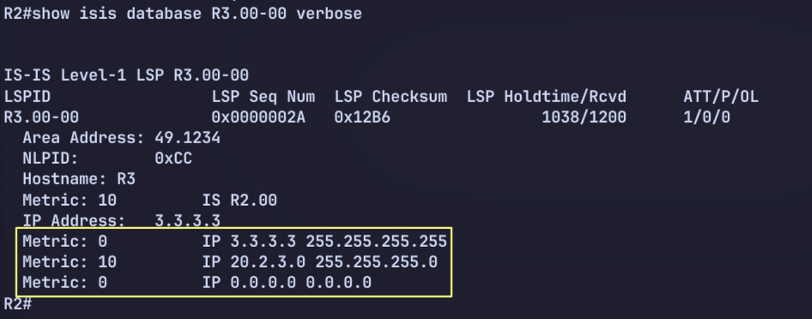

ISIS RIB still has both 0/0 routes generated from the ATT bit set on R3 and R4, but the explicit 0/0 is preferred and installed.
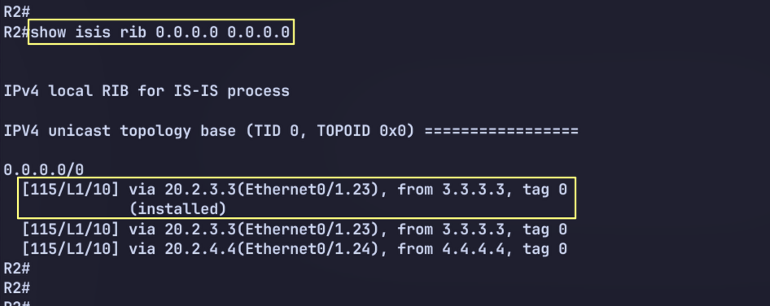

ISIS Timers

Load Config
# IOL
configure replace unix:labconfigs/isis.inter.area.cfg force

# IOS-XR
configure
load config:labconfigs/isis.inter.area.cfg
commit replace confirmed minutes 1
commit

Set R1 and XR2 to use the following ISIS timers:
- Local LSPs should have a max lifetime of 600 seconds. These LSPs should be refreshed every 300 seconds.
- Locally-generated LSPs should be throttled 500 msec after a change, 750 msec if occuring after an LSP was just generated previously, and a max backoff of 3 seconds.
- SPF calculation should be throttled 250 msec after receiving an update, 500 msec if an SPF run has just occured, and a max wait time of 3 seconds.
- Partial route calculation should use the same timers as SPF calculation.
- During flooding, interfaces should pace LSPs at 20 msec intervals
- During flooding, the router should allow for up to 3 seconds before retransmitting the same LSP. If LSPs do need to be retransmitted, these should be paced at 40 msec intervals.

Answer

# R1
router isis
max-lsp-lifetime 600
lsp-refresh-interval 300
spf-interval 3 250 500
prc-interval 3 250 500
lsp-gen-interval 3 500 750
!
int Eth0/1.12
isis lsp-interval 20
isis retransmit-interval 3
isis retransmit-throttle-interval 40

# XR2
router isis 1
max-lsp-lifetime 600
lsp-refresh-interval 300
lsp-gen-interval initial-wait 500 secondary-wait 750 maximum-weight 3000
!
address-family ipv4 unicast
spf-interval initial-wait 250 second-wait 500 maximum-wait 3000
!
int Gi0/0/0/0.1920
lsp-interval 20
retransmit-interval 3
retransmit-throttle-interval 40

Explanation

The max-lsp-lifetime command sets the lifetime on locally generated LSPs. By default this appears to be 1200 seconds. This defines how long an LSP is valid in the LSDB. A longer interval allows for less frequent refreshes, which saves some bandwidth in a large network.

Log Neighbor Changes

Load Config
# IOL
configure replace unix:labconfigs/isis.inter.area.cfg force

# IOS-XR
configure
load config:labconfigs/isis.inter.area.cfg
commit replace confirmed minutes 1
commit

Configure R1 so that when eth0/1.12 is manually shut down, the following log message appears:
%CLNS-5-ADJCHANGE: ISIS: Adjacency to R2 (Ethernet0/1.12) Down, interface deleted(non-iih)
Configure R2 so that when eth0/1.12 on R1 is shut down, no log message appears at all.

Answer
# R1
router isis
log-adjacency-changes all

# R2
router isis
no log-adjacency-changes

Explanation

By default, log-adjacency-changes is enabled. However, this only logs adjacency changes that are detected through the ISIS Hello. If the interface goes down, the adjacency is lost based on the interface, not the missing Hellos, so no log is generated. If we use the all keyword, it will log all adjacency changes, even those caused by non-Hello events.

Troubleshooting 1 – No routes

Load Config

# IOL
configure replace unix:labconfigs/isis.tshoot1.cfg

# IOS-XR
configure
load config:labconfigs/isis.tshoot1.cfg
commit replace confirmed minutes 1
commit

R1 and XR2 have no ISIS routes in the routing table. Fix the issue without disabling any features that have been enabled on any other routers. You may only configure two routers.

Answer

# R1
router isis
metric-style wide / transition

# XR2
router isis 1
address-family ipv4 unicast
metric-style wide / transition

Explanation

If we look at the topology on R1 and XR2, we can see that all routers have ** for the metric. This indicates a metric-style mismatch:

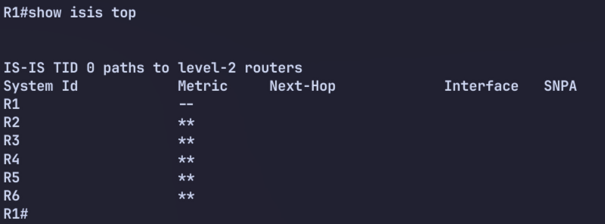
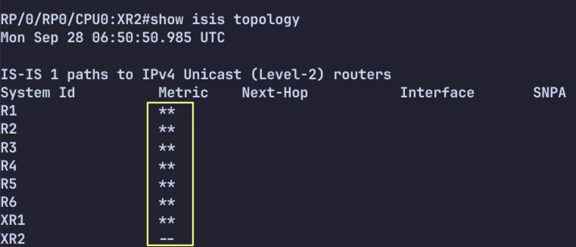
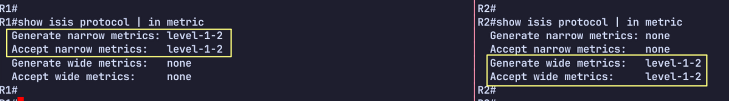

Troubleshooting 2 – Adjacency

Load Config
# R1, R2
configure replace unix:labconfigs/isis.tshoot2.cfg

Fix the broken adjacency between R1 and R2.

Answer

Cisco explains that in IPv6 single-topology IS-IS, routers must have the same set of address families on the same link, and IS-IS performs a consistency check on the IPv6 information within the hello packets. If one side runs IPv4+IPv6 while the other side only runs IPv4, the adjacency can be rejected or encounter issues.

R1 R2
E0/1.12 ─────────────────── E0/1.12

IPv4 IS-IS ✅ IPv4 IS-IS ✅
IPv6 IS-IS ✅ IPv6 IS-IS ❌
IPv6 link-local ✅? IPv6 link-local ❌

alternative option for transition
# R1

router isis
address-family ipv6
no adjacency-check

Explanation
There are several things wrong here. The following must match for an adjacency to come up:
- Common subnet for IPv4
- Protocols supported must match and multitopology mode must match
  - However, if one side uses ST and one uses MT transition, then both IPv4 and IPv6 will work
- Circuit types and router levels must match/be compatible
- Hello auth must match
- MTU must match
The following was broken in this situation:
- R2 has a misconfigured key-string
- R2 is in the wrong IPv4 subnet
- R1 does not use p2p as the circuit type
- R1 is level-1 only, while R2 is level-2 only
- R1 has a larger MTU on the interface. R2 won’t be able to accept fully padded Hellos from R1
- R1 is running IPv6 on the interface and R2 is not
  - IOS-XE uses single-topology by default, in which both IPv4 and IPv6 are required if one side has IPv6 enabled.
  - An alternative would be to enable wide metrics on both sides, and then use multi-topology on R1. This would allow the adjacency to come up without R2 supporing IPv6. This is because each protocol has its own topology now on R1.

Troubleshooting 3

Load Config
# R1..R6
configure replace unix:labconfigs/isis.tshoot3.cfg

All adjacency is up, but R2 to R5 can’t ping R1’s loopback.

Answer
# R1, R2
int eth0/1.12
no isis circuit-type

# R1
router isis
is-type level-1-2

Explanation
All routers are in the same area, but R1-R2 adjacency is L1 only. R1 only know R2, however R2 won’t send default route to R1 because it isn’t connected to other area.
R1#show isis database

IS-IS Level-1 Link State Database:
LSPID LSP Seq Num LSP Checksum LSP Holdtime/Rcvd ATT/P/OL
R1.00-00 * 0x0000001A 0x2E1F 1197/* 0/0/0
R2.00-00 0x00000010 0x8795 1196/1200 0/0/0

IPv6 Single Topology

Load Config
# IOS-XE
config replace unix:labconfigs/isis.ipv6.init.cfg

# IOS-XR
configure
load config:labconfigs/isis.ipv6.init.cfg
commit replace
y
All routers have IPv6 link-local addresses enabled on their interfaces, and a loopback IPv6 address of 2001:db8::<router num>/128.
- Without enabling wide metrics, configure IPv6 reachability between all routers on their loopbacks.

Answer
IOS-XE’s default IPv6 mode is single topology. In single topology, IPv6 “uses” the IPv4 topology. The IPv6 prefixes ride on top of the IPv4 topology and its adjacencies. IPv6 prefixes are simply advertised with TLV 236. This is used whether or not wide metrics are used. (Either can be used with single topology).

The link-local address, used for the nexthop by the neighbor for IPv6 routes, is advertised in the Hello in the IPv6 interface address TLV (232).
On IOS-XR, we must enable single-topology under the AFI. By default IOS-XR uses multi topology, in which IPv4 and IPv6 each have a separate topology, and IPv6 is not required to be enabled on every interface.
In summary:
- IPv6 can be used with either single topology or multi topology
  - In single topology, IPv6 uses the IPv4 topology. IPv6 prefixes are advertised in a separate IPv6 reachability TLV (236)
- Single topology is the default mode on IOS-XE
- Multi topology is the default mode on IOS-XR
- In single topology, every link must have both IPv4 and IPv6. If any router does not have IPv6 enabled, both IPv4 and IPv6 reachability is broken.
  - This is because the adjacency requires all protocols be supported between both neighbors
  - The exception is that you can use single topology and only IPv6. No IPv4 anywhere in the topology. In this case, the protocols supported TLV lists only IPv6 by itself.
- Single topology can use either narrow or wide metrics. Multi topology requires wide metrics.

IPv6 Single Topology Challenge

Load

# IOS-XE
config replace unix:labconfigs/isis.st.challenge.init.cfg

# IOS-XR
configure
load config:labconfigs/isis.st.challenge.init.cfg
commit replace
y
- R1 and XR2 have enabled IPv6 support using ST mode.
- R2 and XR1 have not yet implemented IPv6.
- The operator has found that the adjacencies between R1-R2 and XR1-XR2 are now broken.
- Find a way to fix this without enabling IPv6 support on R2 or XR1, and without disabling IPv6 support on R1 or XR2.

Answer

# R1
router isis
address-family ipv6
no adjacency-check

# XR2
router isis 1
address-family ipv6 unicast
adjacency-check disable
!
!

Explanation
A router that enables IPv6 on an interface using ST mode requires that the neighbor supports both IPv4 and IPv6 in the protocols supported TLV. If the neighbor only supports IPv4, the router will not bring the adjacency up.

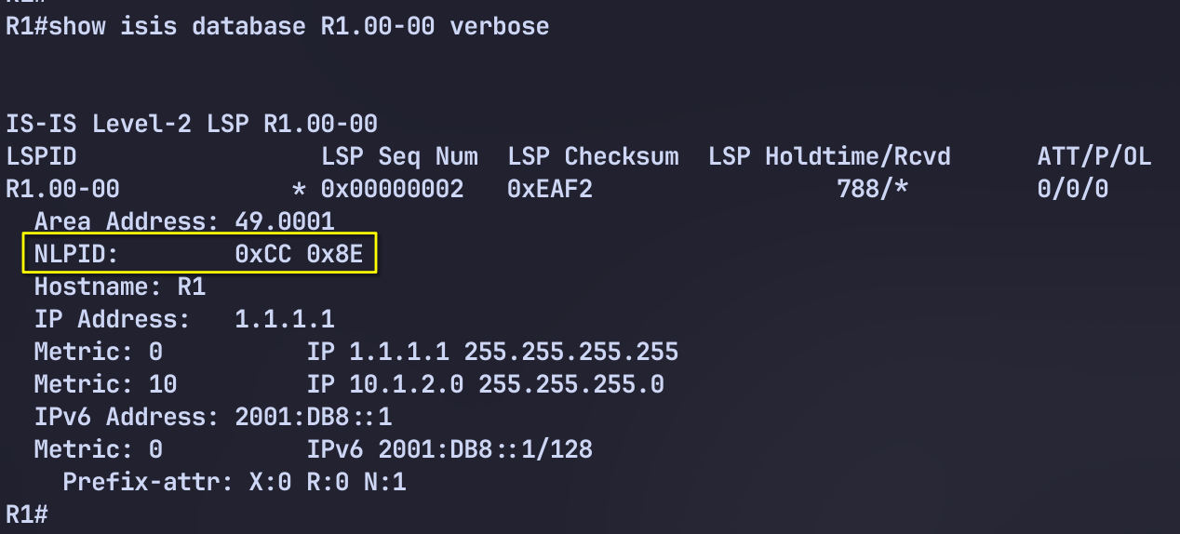
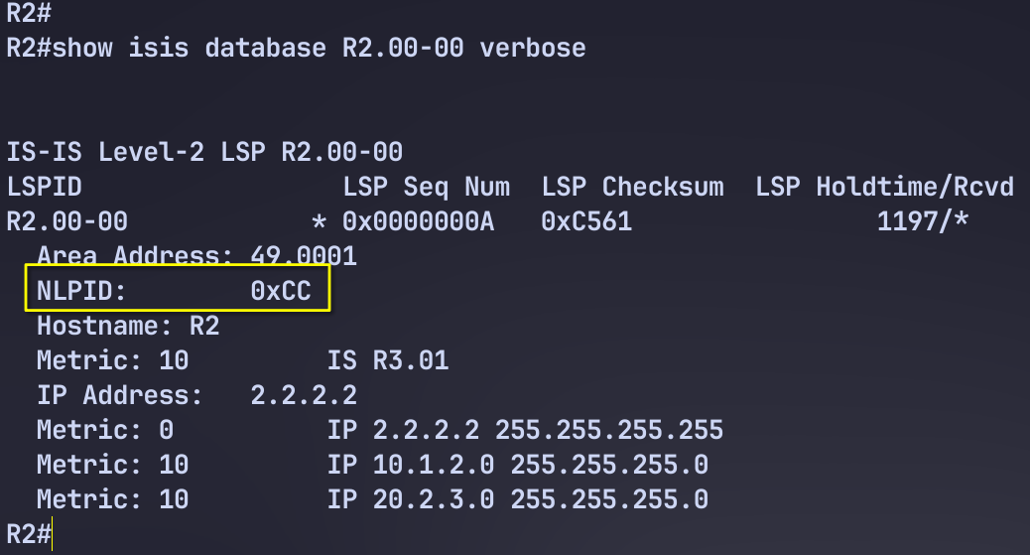
To get around this, we can configure the router to disable this adjacency check.

IPv6 Multitopology

Load Config
# IOS-XE
config replace unix:labconfigs/isis.ipv6.init.cfg

# IOS-XR
configure
load config:labconfigs/isis.ipv6.init.cfg
commit replace
y

All routers have IPv6 link-local addresses enabled on their interfaces, and a loopback IPv6 address of 2001:db8::<router num>/128.
Configure IPv6 reachability using multi topology.

Answer
# IOS-XE
router isis
metric-style wide
address-family ipv6
multi-topology
int xxx
ipv6 router isis

# IOS-XR
router isis 1
address-family ipv4 unicast
metric-style wide
!
interface Loopback0
address-family ipv6 unicast
!
!
interface GigabitEthernet0/0/0/0.1920
address-family ipv6 unicast

Explanation

show isis ipv6 topology
show isis topology

# ios-xr
show isis database verbose | utility egrep "NLPID|00-00"

# ios-xe
show isis database verbose | in NLPID|00-00

IPv6 Single to Multitopology

Load Config
# IOS-XE
config replace unix:labconfigs/isis.ipv6.st.cfg

# IOS-XR
configure
load config:labconfigs/isis.ipv6.st.cfg
commit replace
y

All routers have IPv6 link-local addresses enabled on their interfaces, and a loopback IPv6 address of 2001:db8::<router num>/128.
Single-topology IPv6 has already been setup. Migrate to Multi-topology for IPv6 without breaking IPv4 or IPv6 reachability.

Explanation
In phase one, we first enable wide-metrics everywhere. This is because MT on IOS-XE requires wide metrics. We enable it using the transition method, in which both narrow and wide metrics are generated and received.

# IOS-XE
router isis
Metric-style transition

# IOS-XR
Router isis 1
address-family ipv4
Metric-style transition

Now we can remove the transition style and use only wide-metrics.

# IOS-XE
router isis
metric-stydde

# IOS-XR
Router isis 1
address-family ipv4
Metric-style wide

In phase two we enable multi-topology on all routers but with the transition keyword. This forces the router to continue generating the IPv6 reachability TLV which is used in single-topology.

# IOS-XE
router isis
add ipv6
multi-topology transition

# IOS-XR
router isis 1
address-family ipv6
no single-topology !!! no transition mode on IOS-XR

Note that we lost reachability on XRv neighbors with this step because we had to enable multi-topology only. There is no “transition” mode in which XRv continues generating normal ST IPv6 prefix reachability TLVs. Specifically, when making the change first on routers R1-R6, and then on XR1, XR1 loses its reachability to XR2 prefixes. But it still has reachability to all routers R1-R6. We then turn ST off on XR2, and reachability is restored.
Now that all routers are running MT, we can turn the transition mode off.

# IOS-XE
router isis
add ipv6
multi-topology

Summary
The transition keyword for multi-topology is only available on IOS-XE. When you use this keyword, the router continues generating IPv6 reachability TLVs (236) in addition to the MT IPv6 reachable prefixes TLV (237). This allows other routers that are still running in ST mode to continue to work.

Wide Metrics

Load Metric

# CSR
configure replace tftp://10.0.0.2/configs/isis.inter.area.cfg

# IOS-XR
configure
load config:labconfigs/isis.inter.area.cfg
commit replace confirmed minutes 1
commit

Narrow metric TLVs is 6 bits, so the max value is 63.

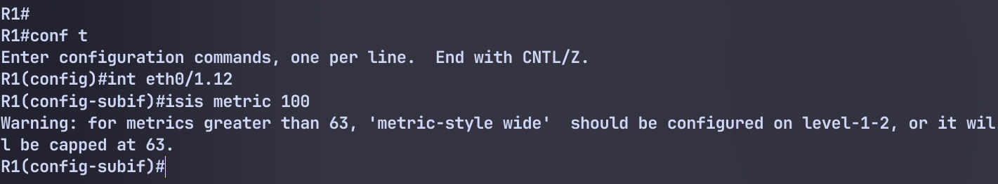
Redistribute a route on R1 into level 1 and notice the behavior.

# R1
int lo100
ip add 100.1.1.1 255.255.255.255
!
route-map LO100
match int lo100
!
router isis
redistribute connect route-map LO100 level-1

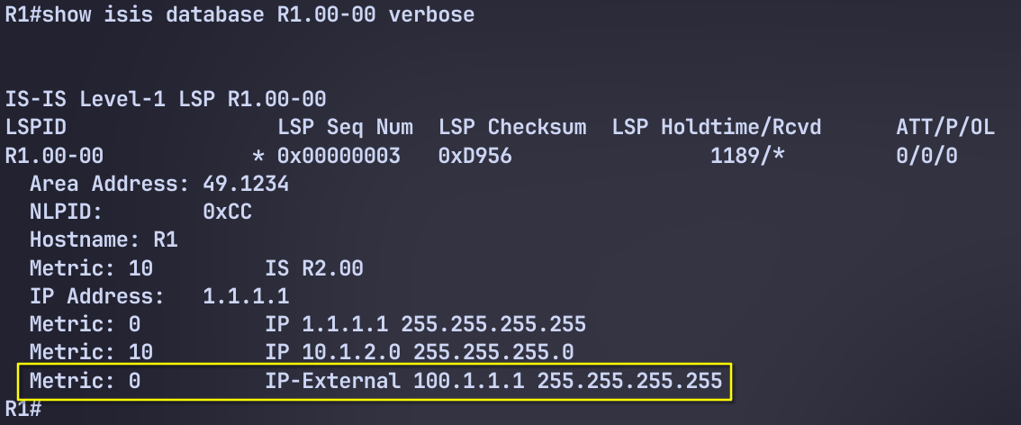

# R1
#R1
router isis
metric-style transition

Route Filtering
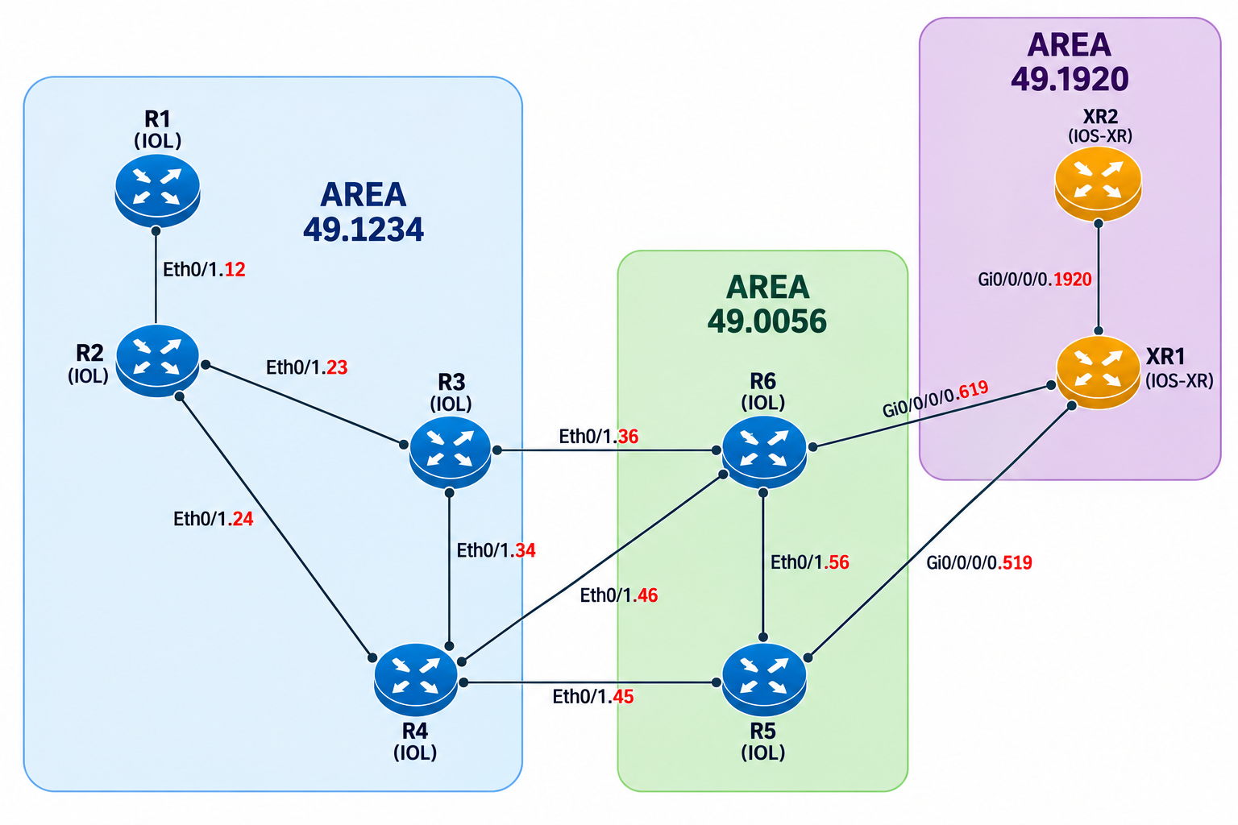

Load Config
# IOS-XE
config replace unix:labconfigs/isis.inter.area.cfg

# IOS-XR
configure
load config:labconfigs/isis.inter.area.cfg
commit replace
y

On XR2, configure Lo20 with IP 200.20.20.20/32. Redistribute this into ISIS with tag=20.
On R3 and R4, filter routes with tag=20 from being redistributed into L1. Allow all other L2 routes to be redistributed.

Answer
First we must switch to wide-style metrics to use tags. The narrow metric external IP reachability TLV does not have a tag field.

Redistribute with correct tag
# XR2

int Lo20
ip add 200.20.20.20/32
!
route-policy lo20
if destination in ( 200.20.20.20/32 ) then
set tag 20
endif
end-policy
!
router isis 1
address-family ipv4 unicast
redistribute connected level-1 route-policy lo20

On R3 and R4 we redistribute all L2 routes into L1 except for tag 20:

# R3, R4
route-map nolo20 deny 5
match tag 20
route-map nolo20 permit 10
!
router isis
redistribute isis ip level-2 into level-1 route-map nolo20

Backdoor Link

Load Config
# IOS-XE
config replace unix:labconfigs/isis.inter.area.cfg

# IOS-XR
configure
load config:labconfigs/isis.inter.area.cfg
commit replace
y

Configure an additional link between R1 and XR2, using vlan 120 with subnet 20.1.20.0/24.
Configure this link so that area 49.1234 and 49.1920 can reach each other directly without traversing the L2 backbone.
Do not let traffic destined for any other areas run over this link.

Answer
# R1
router isis
is-type level-1-2 backdoor

# XR2
router isis 1
address-family ipv4 unicast
attached-bit send never-set

Explanation
The backdoor feature configures a L1/L2 router to do two things:
- Not set the ATT bit in L1 LSPs
- Continue installing a default route via other L1 routers that have the ATT bit set
On IOS-XE this is configured with is-type level-1-2 backdoor. On IOS-XR this is configured using attached-bit send never-set.

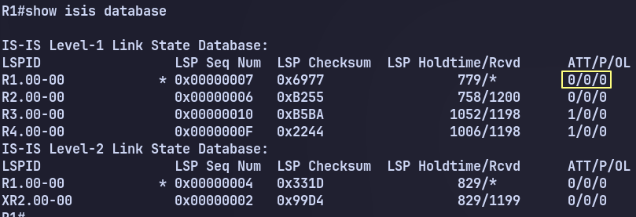
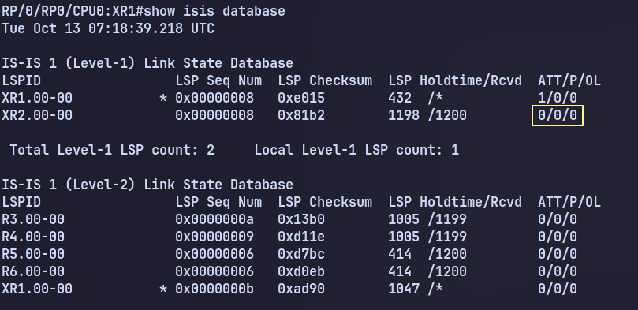

Non-Optimal Intra-Area Routing

Load Config
# IOS-XE
config replace unix:labconfigs/isis.non-optimal.intra-area.cfg

# IOS-XR
configure
load config:labconfigs/isis.non-optimal.intra-area.cfg
commit replace
y

R1 is now connected to both R3 and R4.

Shutdown the R1-R3 link and do a traceroute to 1.1.1.1 from R3. Traffic is from R3 to R1 is flowing to R2-R4-R1 instead of R4-R1. Explain the issue and find a way to fix it so that traffic takes the path R4-R1.

Answer
# R3, R4
interface eth0/1.34
isis circuit-type level-1-2

Explanation

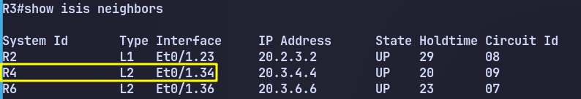

The reason for this non-optimal routing is because the R3-R4 link is level-2-only.
Routers prefer intra-area routes over inter-area routes. This means an L1 route is preferred over an L2 route.
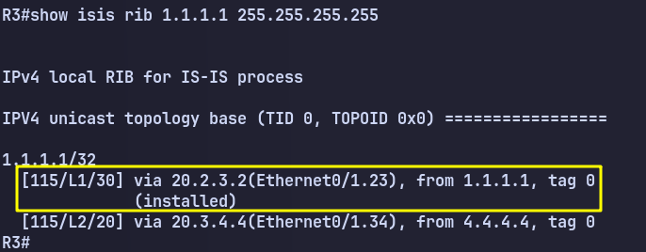
Even though R3 and R4 are in the same area, they only have an L2 adjacency. The route to 1.1.1.1 via R4 is an L2 route, which although a shorter metric, loses against the higher metric L1 route via R2.

Multi Area

Load Config
# IOS-XE
config replace unix:labconfigs/isis.multi.area.cfg

# IOS-XR
configure
load config:labconfigs/isis.multi.area.cfg
commit replace
y

All routers are pre-configured in their respective ISIS areas. All links are L1-only except for Eth0/1.36 on R3 and R6.
Without changing the L1-only areas or changing the circuit types, fix the design so that inter-area routing is achieved.

Answer

# R3
router isis
net 49.0012.0000.0000.0003.00
net 49.0004.0000.0000.0003.00

# R6
router isis
net 49.1920.0000.0000.0006.00
net 49.0005.0000.0000.0006.00

Explanation
The solution to this involves setting multiple NET addresses on R3 and R6. This allows these routers to participate in multiple ISIS areas.
The problem is that ISIS by default allows up to 3 areas on a single router. This is a negotiated value in the ISIS hello. R6 will need to participate in 4 areas. So first, we would change the maximum areas supported on all routers to 4.

Unfortunately, IOS-XR does not support a different max-area-address number besides 0 or 3. (0 implies a value of 3). So we cannot use this solution.
Instead we will have to leave the default at 3 max addresses and not create an adjacency between R4-R6. We will configure R3 and R6 with additional NET addresses.

Authentication
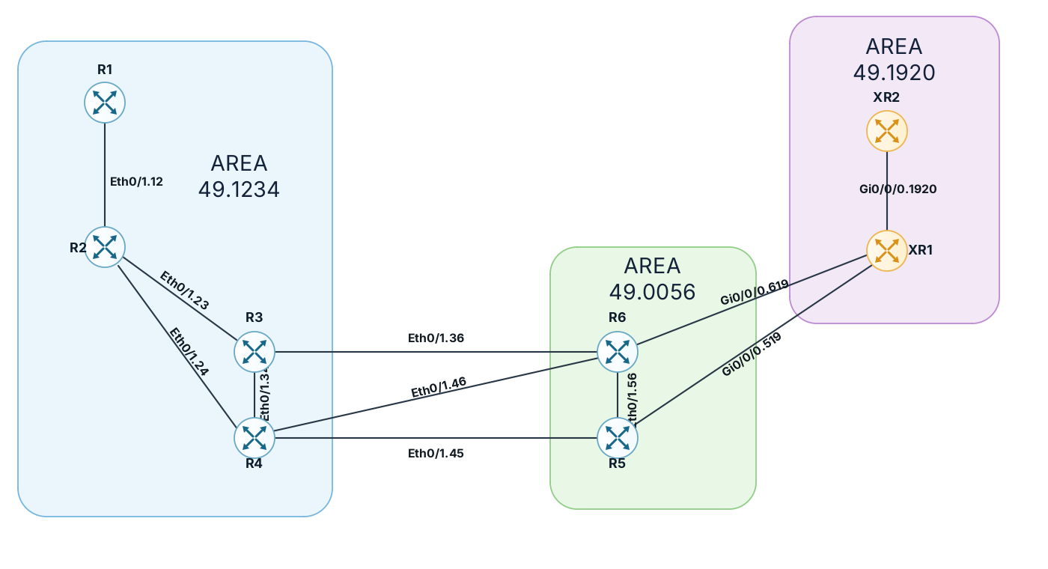
Figure 0-2 ISIS InterArea

Load Config
# IOS-XE
config replace unix:labconfigs/isis.inter.area.cfg

# IOS-XR
configure
load config:labconfigs/isis.inter.area.cfg
commit replace
y

Configure area 49.1234 as follows:
- R1-R2 should use HELLO123 as the hello password using the legacy syntax
- R2-R3-R4 should all use HELLO234 as the password using MD5.
- The area should authenticate L1 LSPs and SNPs using “AREA1234” in clear text, but they should all be accepted if they do not contain authentication. Use the legacy syntax for this.
Configure area 49.0056 as follows:
- R5-R6 should use HELLO56 as the hello password in plain text using the new syntax. Allow received Hellos to not contain authentication, or to contain wrong authentication.
- The area should authenticate L1 LSPs and SNPs using “AREA56” in clear text. LSPs and SNPs should be accepted without authentication. Use the new syntax for this.
Configure area 49.1920 as follows:
- XR1-XR2 should use HELLO1920 as the hello password using MD5.
- The area should authenticate L1 LSPs and SNPs using “AREA1920” with MD5.
Configure authentication the entire domain as follows:
- All inter-area L2 adjacencies should use the password “LEVEL2” with MD5
- All L2 LSPs/SNPs shoud use the password “LEVEL2” with MD5, but all LSPs/SNPs should be accepted without authentication.

Answer
# R1

int Eth0/1.12
isis password HELLO123
!
router isis
area-password AREA1234 authenticate snp send-only

# R2
int Eth0/1.12
isis password HELLO123
!
int Eth0/1.23
isis authentication mode md5
isis authentication key-chain ISIS_HELLO
!
int Eth0/1.24
isis authentication mode md5
isis authentication key-chain ISIS_HELLO
!
router isis
area-password AREA1234 authenticate snp send-only
!
key chain ISIS_HELLO
key 1
key-string HELLO234

# R3
int Eth0/1.23
isis authentication mode md5
isis authentication key-chain ISIS_HELLO
!
int Eth0/1.34
isis authentication mode md5
isis authentication key-chain ISIS_HELLO
!
int Eth0/1.36
isis authentication mode md5
isis authentication key-chain ISIS_HELLO_L2
!
router isis
area-password AREA1234 authenticate snp send-only
authentication mode md5 level-2
authentication key-chain ISIS_DOMAIN_AUTH level-2
authentication send-only level-2
!
key chain ISIS_HELLO
key 1
key-string HELLO234
!
key chain ISIS_HELLO_L2
key 1
key-string LEVEL2
!
key chain ISIS_DOMAIN_AUTH
key 1
key-string LEVEL2

# R4
int Eth0/1.24
isis authentication mode md5
isis authentication key-chain ISIS_HELLO
!
int Eth0/1.34
isis authentication mode md5
isis authentication key-chain ISIS_HELLO
!
int Eth0/1.46
isis authentication mode md5
isis authentication key-chain ISIS_HELLO_L2
!
int Eth0/1.45
isis authentication mode md5
isis authentication key-chain ISIS_HELLO_L2
!
router isis
area-password AREA1234 authenticate snp send-only
authentication mode md5 level-2
authentication key-chain ISIS_DOMAIN_AUTH level-2
authentication send-only level-2
!
key chain ISIS_HELLO
key 1
key-string HELLO234
!
key chain ISIS_HELLO_L2
key 1
key-string LEVEL2
!
key chain ISIS_DOMAIN_AUTH
key 1
key-string LEVEL2

# R5
key chain ISIS_HELLO
key 1
key-string HELLO56
!
key chain ISIS_AREA
key 1
key-string AREA56
!
key chain ISIS_HELLO_L2
key 1
key-string LEVEL2
!
key chain ISIS_DOMAIN_AUTH
key 1
key-string LEVEL2
!
int Eth0/1.56
isis authentication mode text
isis authentication key-chain ISIS_HELLO
isis authentication send-only
!
int Eth0/1.45
isis authentication mode md5
isis authentication key-chain ISIS_HELLO_L2
!
int Eth0/1.519
isis authentication mode md5
isis authentication key-chain ISIS_HELLO_L2
!
router isis
authentication mode text level-1
authentication send-only level-1
authentication key-chain ISIS_AREA level-1
authentication mode md5 level-2
authentication key-chain ISIS_DOMAIN_AUTH level-2
authentication send-only level-2

# R6
key chain ISIS_HELLO
key 1
key-string HELLO56
!
key chain ISIS_AREA
key 1
key-string AREA56
!
key chain ISIS_HELLO_L2
key 1
key-string LEVEL2
!
key chain ISIS_DOMAIN_AUTH
key 1
key-string LEVEL2
!
int Eth0/1.56
isis authentication mode text
isis authentication key-chain ISIS_HELLO
isis authentication send-only
!
int Eth0/1.36
isis authentication mode md5
isis authentication key-chain ISIS_HELLO_L2
!
int Eth0/1.46
isis authentication mode md5
isis authentication key-chain ISIS_HELLO_L2
!
int Eth0/1.619
isis authentication mode md5
isis authentication key-chain ISIS_HELLO_L2
!
router isis
authentication mode text level-1
authentication send-only level-1
authentication key-chain ISIS_AREA level-1
authentication mode md5 level-2
authentication key-chain ISIS_DOMAIN_AUTH level-2
authentication send-only level-2

# XR1
router isis 1
lsp-password hmac-md5 AREA1920 level 1
lsp-password hmac-md5 LEVEL2 level 2 send-only
!
int gi0/0/0/0.1920
hello-password hmac-md5 HELLO1920
!
int gi0/0/0/0.619
hello-password hmac-md5 LEVEL2
!
int gi0/0/0/0.519
hello-password hmac-md5 LEVEL2

# XR2
router isis 1
lsp-password hmac-md5 AREA1920 level 1
!
int gi0/0/0/0.1920
hello-password hmac-md5 HELLO1920

BGP

Russo – Lab 1 ECMP

Load Config
# R1 – R6
config replace unix:labconfigs/bgp.russo-lab1.cfg force

The idea behind these labs is that R6 is advertising 192.0.2.6/32 and 2001:db8::6/128. It is multi-homed to R4 and R5. We will use various techniques to achieve load balancing and failover.
This first lab requires you to configure ECMP.
Currently R2 and R3 are using R4 for egress due to its lower RID. R6 is using R4 for this reason as well.
Configure the fewest number of routers so that traffic from R1 to R6 is load balanced through R4 and R5, and return traffic from R6 is likewise load balanced.

Answer
# R3
router bgp 65000
address-family ipv4
maximum-paths ibgp 2
address-family ipv6
maximum-paths ibgp 2

# R6
router bgp 65006
address-family ipv4
maximum-paths 2
address-family ipv6
maximum-paths 2

Explanation
We do not need to enable iBGP multipath on R2, it will always use R3 to get to R4 and R5, so enabling multipath does not technically achieve anything. It can be done, but the result is the same with or without it.

Russo – Lab 2 UCMP
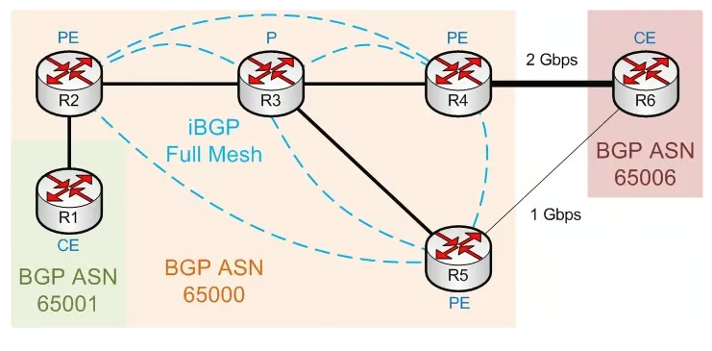

Load Config
# R1 – R6
config replace unix:labconfigs/bgp.russo-lab2.cfg force
The bandwidth of the R4-R6 and R5-R6 link has been changed, matching the diagram above.
- Configure UCMP so that R3 will send twice as much traffic to R4.
- Additionally, configure R6 to send twice as much traffic to R4.
- Only do this for IPv4 traffic. (It doesn’t work for IPv6).

Answer
# R3
router bgp 65000
add ipv4
maximum-paths ibgp 2
bgp dmzlink-bw

# R4
router bgp 65000
template peer-policy IBGP_V4V6
send-community both
exit-peer-policy
add ipv4
bgp dmzlink-bw
neighbor 10.4.6.6 dmzlink-bw

# R5
router bgp 65000
template peer-policy IBGP_V4V6
send-community both
exit-peer-policy
add ipv4
bgp dmzlink-bw
neighbor 10.5.6.6 dmzlink-bw

# R6
router bgp 65006
add ipv4
bgp dmzlink-bw
neighbor 10.4.6.4 dmzlink-bw
neighbor 10.5.6.5 dmzlink-bw
maximum-paths 2

Explanation
